**STRIPE PAYMENT INTEGRATION IN REACT JS**

**STEP 1:** Visit the website 🡪 <https://stripe.com/en-in>

**STEP 2:** sign in

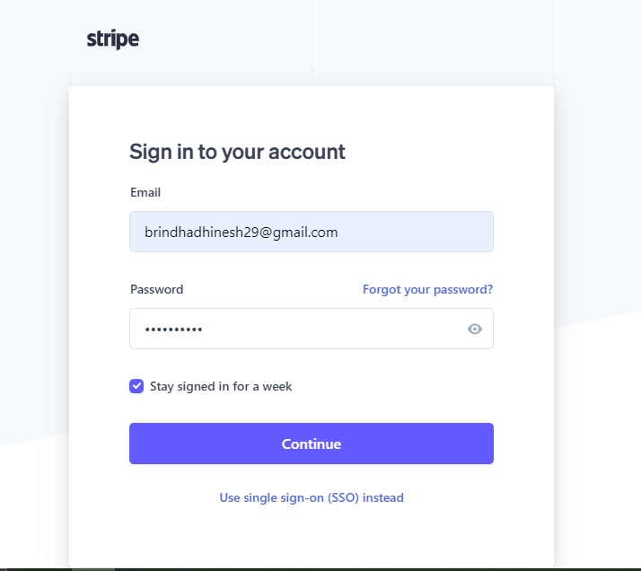

**STEP 3:** Click on developers tab.

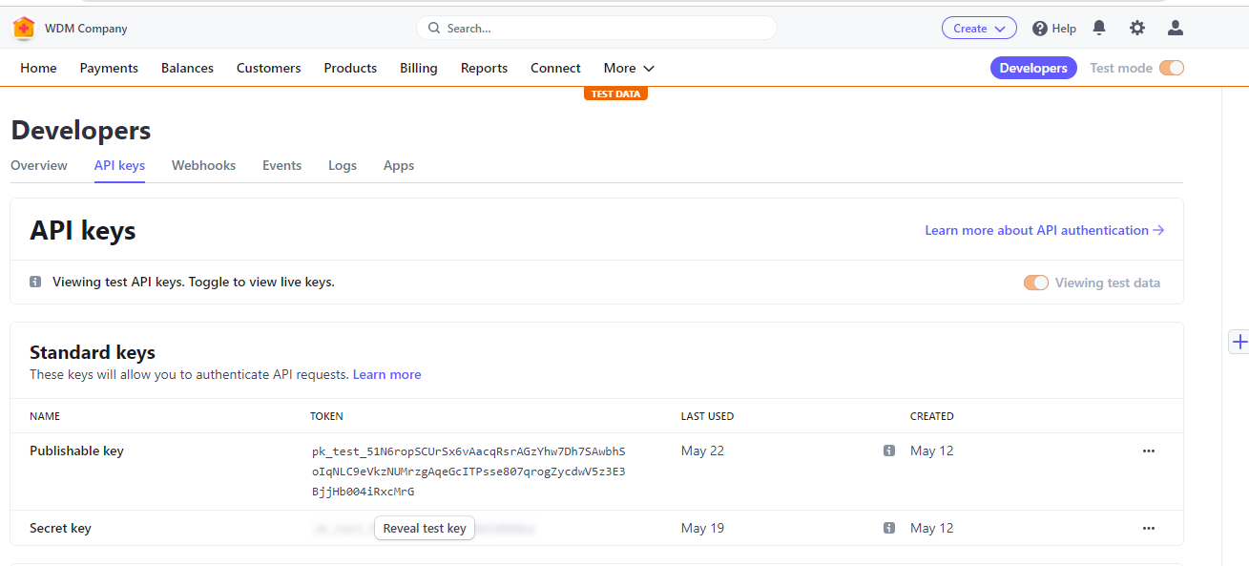

**STEP 4:** Then create new react project.

**STEP 5:**  Refer code sandbox Link 🡪 <https://codesandbox.io/s/omfb3?file=/src/App.js>

**STEP 6:**  Also refer this link 🡪 <https://codesandbox.io/s/react-stripe-js-q1loc?file=/package.json>

**STEP 7:**  npm install the latest version

@stripe/react-stripe-js  
@stripe/stripe-js

**STEP 8:**  After npm start, fill the required details

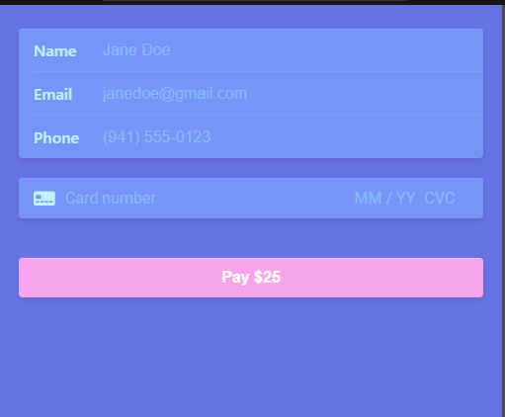

**STEP 9:**  view the payment transaction detail in give link 🡪

<https://dashboard.stripe.com/test/logs?method[0]=post&method[1]=delete&direction[0]=connect_in&direction[1]=self>

